Capstone Project Gabriel Verzea
Machine Learning Engineer Nanodegree October 15th, 2018

Identifying edible wild plants

- Definition

Project Overview

Fuel keeps our cars running, and food is the fuel for our bodies. We can survive many days without food, but if we have to keep moving, the lack of food will slow us down and eventually bring us to a stop. I am an amateur ultrarunner and one too many times I have failed to plan, and thus found myself on a trail, away from civilization, hungry and out food. At that times, I had hoped I had shown more interest in the art of foraging, but there I was, with a lot of vegetation around me, and not knowing what was edible. I wish I had a phone app that would identify the edible plants around me...

The project aims to identify a number of 62 different wild edible plants, and once the plant is identified, provide info on the plant name and edible parts of that plant. Given a picture, it will say if the picture represents any of the 62 plants it has been trained on, or not.

The final application of this model would be to be packaged in an Android or iPhone app, that would then be able to make predictions for images taken in the wild – but this is out of scope for the current project.

A similar computer vision problem is described in the article Wäldchen, J. & Mäder, P. Arch Computat Methods Eng (2018) 25: 507. Here, a number of plants are recognized mainly based on leafs and flowers, using a number of features as Shape, Color, Texture and Leaf.

Problem Statement

The problem to be solved is – given a picture, the model should predict if this picture represents one of the 62 plant types from the dataset, or if it does not.
To achieve this, the following tasks are to be undertaken:
- Read the training data
- Preprocess the data (resize, crop, normalization, augmentation) to be ready to be inputted into a CNN
- Build a CNN that would have as an output layer a choice of one of the 62 classes to be predicted
- Based on the level of confidence that the model has in the prediction, decide if the input image does represent any of the 62 classes, or not (eg. if confidence level < 0.8, then the picture does not represent any of the given classes.

Metrics

The initial metric I had in mind, was precision. However, it seems that as of Keras 2.0, precision and recall were removed from the master branch, so I decided to stick with accuracy.

Here is how accuracy is calculated:
True positive (TP) = the number of cases correctly identified as patient
False positive (FP) = the number of cases incorrectly identified as patient
True negative (TN) = the number of cases correctly identified as healthy
False negative (FN) = the number of cases incorrectly identified as healthy

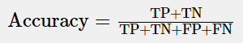

False negatives are damaging the user experience, as he misses out on plants that he could eat. But false positives could potentially be even worse, if the user is encouraged to eat a certain plant that might not really be edible. So the specificity would be more important than the sensitivity, for this problem.

- Analysis

Data Exploration

After I have made up my mind on the project topic, I started looking for data. Unfortunately I could not find something readily downloadable. I did find a small flowers recognition dataset on Kaggle, with 5 plants, out of which 3 were overlapping with my classes, and I got the approval of its creator to reuse those pics. But for the rest of the 59 plant categories, I had to manually select pictures from the internet. I have decided to gather 50 images of each, and after the model was built, see if I needed to gather more, for some of the categories, where the model would be struggling. That worked fine, and I ended up with having between 50 and 150 pictures for those 59 categories.

The obvious disadvantage of gathering data manually is speed, and the low volume of data, but on the other side, this solves the problem of the outliers – because all input data has been vetted manually, it does not run the risk of having outliers.

To keep the database size under control, I have resized all images to under 300kB.

The gathered pictures are in .jpg format. The color profile of a JPG image is YCbCr, which is a mathematical coordinate transformation from an associated RGB color space, according to wikipedia.

Exploratory Visualization

Below is a graph with the amount of pictures per each class in the training dataset – 6558 images in total, split between 62 classes, in the dataset folder. The 3 classes where I got the free pictures from the existing Kaggle dataset clearly stand out.

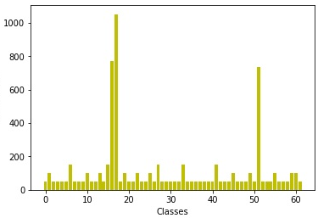

For testing, I have gathered an additional 310 pictures (5 pictures per class) in the dataset-test folder. There are a few other pictures, non-labeled, that are supposed to be uploaded by the users to test the model, in the folder dataset-user_images.

Images from the edible wild plants dataset:

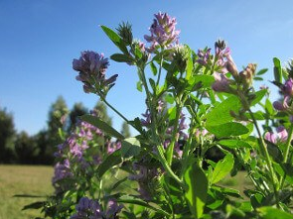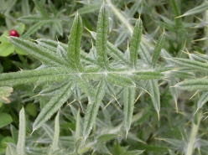
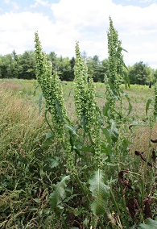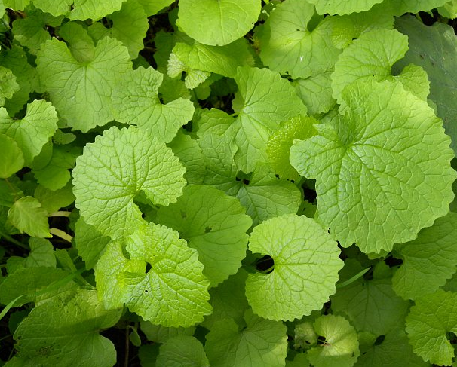

The dataset contains:
“dataset” folder – for training the model
“dataset-test” folder – for testing the model
“dataset-user_images” – for user uploaded images
“edible wild plants metadata.xls” – excel file with a description of the classes and the edible parts of the plants.

The first 2 folders contain 62 sub-folders each, with the labels as folder names.

Algorithms and Techniques

The gathered pictures will be used to train/test the model. To preserve class balances across the train/test datasets, I have used the StratifiedKFolds cross-validator. It provides train/test indices to split data in train/test sets. This cross-validation object is a variation of KFold that returns stratified folds. The folds are made by preserving the percentage of samples for each class.

This also allows using all the pictures in the dataset for both training and dev evaluation, by splitting the dataset into k batches, and training the model k times on k-1 batches, and evaluating it on the remaining batch, on each iteration. This is helpful when the dataset is rather limited in size, like in my case.

The VGG16 model takes by default images of 224x224px, but due to the computing power restrictions of my laptop’s GPU, I have decided to bring the input size even lower, to 100x100px.

Benchmark

The random guess accuracy for the current problem would be1/62 = 0.016. So any model should do better than this.

For the benchmark model I have chosen a simple vanilla CNN.

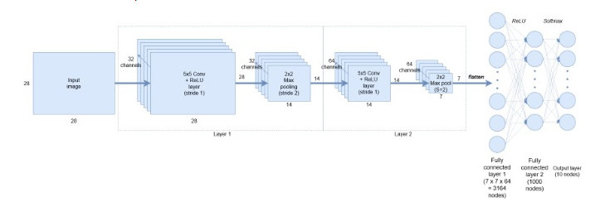

The model contains 2 Conv layers, separated by a Pooling layer each, to reduce the number of parameters, and to make the feature detection invariant to scale and orientation changes. To connect the output of the pooling layer to the last 2 fully connected layers, we need to flatten this output into a single tensor. The last fully connected layer contains the softmax to the 62 classes.

The model yields an accuracy of 0.69 on the dev set and 0.14 on the test set.

- Methodology

Data Preprocessing

The images are in .jpg format. The dimensions were not manually standardized, but this will be one step of the data preparation – to bring all the images to 100x100px. I have also made sure that no image exceeds 300KB, to keep the database within reasonable size limits.

As the dataset is gathered off the internet, the pictures come in different sizes and quality levels. At first I would need to pre-process the data. I would perform the following actions:
- Obtain a uniform aspect ratio – by cropping to squares (centered), and as well by resizing and cropping, maintaining the full image, but at a reduced scale. In this second case, padding is used, when needed.
- Perform Image scaling – scale to 100x100px
- Normalize image inputs – this makes convergence faster while training the network. Data normalization is done by subtracting the mean from each pixel, and then dividing the result by the standard deviation
- Perform Data Augmentation – generate more pictures from the existing ones, by rotation, scaling or flipping – I did this directly with Keras, when fitting the model, with the ImageDataGenerator, I have chosen to rotate images up to 20 degrees, shift them and flip them horizontally. Furthermore, for each epoch, the model was training on a number of steps_per_epoch * batch_size images, which summed up to 1200*32 = 38400 images, instead of the 6558 images in my training dataset.

I have processed the images with the help of the OpenCV library. Currently OpenCV supports a wide variety of programming languages like C++, Python, Java etc. OpenCV-Python is the Python API of OpenCV. It combines the best qualities of OpenCV C++ API and Python language.

Due to the fact that the images have been manually selected, there was no need to identify and remove outliers.

Implementation

The solution I implemented is using deep learning, to be more specific, CNNs, to help a model learn a number of features about the training pictures. My target was that it would yield an accuracy of at least 60% on the test dataset.

A CNN network is a series convolution + pooling operations, followed by a number of fully connected layers. If we are performing multiclass classification the output is softmax

The main building block of CNN is the convolutional layer. Convolution is a mathematical operation to merge two sets of information. In our case the convolution is applied on the input data using a convolution filter to produce a feature map. When presented with a new image, the CNN doesn’t know exactly where these features will match so it tries them everywhere, in every possible position. In calculating the match to a feature across the whole image, we make it a filter. The math we use to do this is called convolution. To calculate the match of a feature to a patch of the image, simply multiply each pixel in the feature by the value of the corresponding pixel in the image. Then add up the answers and divide by the total number of pixels in the feature.

After a convolution operation we usually perform pooling to reduce the dimensionality. This enables us to reduce the number of parameters, which both shortens the training time and combats overfitting. Pooling layers down-sample each feature map independently, reducing the height and width, keeping the depth intact. I have used max pooling which just takes the max value in the pooling window. Contrary to the convolution operation, pooling has no parameters. It slides a window over its input, and simply takes the max value in the window.

After the convolution + pooling layers we add a couple of fully connected layers to wrap up the CNN architecture.

I have built my model using transfer learning. I have chosen the VGG16 model, and I first had to import the weights of the VGG16 model, trained on ImageNet. ImageNet is a project which aims to provide a large image database for research purposes. It contains more than 14 million images which belong to more than 20,000 classes (or synsets)

I have removed the output layer, and replaced it with a series of custom layers: two Dense layers, with dropout, and a softmax layer at the end, with the 62 classes. I have added the two Dense layers with Dropout because I have noticed that the model tends to overfit quite a lot.

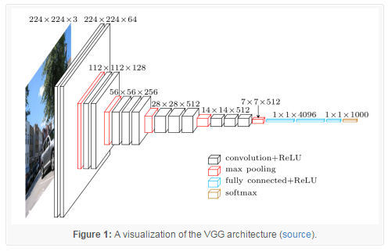

When predicting the class for the user images, I am also printing the confidence level that the model had in predicting the class. If he confidence level is under 80%, I consider that the image does not represent any of the plant classes in the dataset.

I am also displaying details about the respective predicted plant, like what parts, and under which circumstances, are edible.

Refinement

Not unexpected from a deep architecture, the main problem I faced was overfitting on the training dataset. To address the overfitting problem, I have taken the following actions:
- I have added 2 Dropout layers at the end of the model, with 0.8 Dropout. I found this to be the optimal value for the test dataset, as I have experienced also with other values for dropout: 0.5, 0.6, 0.7 and 0.9
- I have added more data (50 to 100 more images per class), especially for the classes where the model was not predicting any of the test images correctly, or only one.
- I have used data augmentation, to multiply the training examples, for the same purpose as the point above. Data augmentation includes things like randomly rotating the image, zooming in, adding a color filter etc. Data augmentation only happens to the training set and not on the validation/test set.
- I have tweaked the parameters of the model, I have played with different values for the learning rate (0.001 and 0.0001) and I found out that 0.0001 works the best, as well as momentum (0.6, 0.7, 0.8, 0.9) and I found out that 0.7 works out the best

To save computing power, I have frozen the first 10 levels of the VGG-16 model. I have tried with freezing 6, 10, 14 and 18 layers, and 10 frozen layers brought the best accuracy.

Although the overfitting problem was not completely solved, the above actions did help raise the accuracy from an initial 0.23. to 0.60 on the training dataset.

- Results

Model Evaluation and Validation

The final model, a CNN making use of transfer learning and based on a VGG16 architecture makes sense for the selected problem. It is an industry-standard model that fits well to the limited time and computational resources of the problem.

The model has separate datasets for training/dev and test, so there is no risk of training of the test data.

The model is robust enough, provided that it is asked reasonable questions. For example, if the model has seen mostly the flowers of a plant, and in the test dataset, it is asked to recognize the same plant by only its leaves, it will not provide a satisfactory answer. This is something that would be solved by providing large number of training images for all parts of the plant, but was not feasible at this stage.

Given the actual dataset, the hyper parameters (learning rate, momentum) were tuned to yield maximum accuracy on the dev dataset with minimum overfitting - maximum accuracy also on the test dataset.

The model performs reasonably well if the picture of the plant to be identified is very clear, but still needs improvement if the picture is somewhat unclear, or if it contains only limited parts of the plant.

Justification

The VGG16-based model has yielded a final 0.997 accuracy on the dev dataset and a 0.606 accuracy on the test dataset.

The benchmark’s model accuracy is 0.699 on the dev dataset and 0.141 on the test dataset.

So the main model clearly outperforms the benchmark. But there is still much room for improvement. I would say that the final solution, at this moment, can be considered a successful prototype, but still needs more work to be done to reach a productive level.

- Conclusion

Free-Form Vizualization

For the free-form visualization, I have chosen to show the confusion matrix. This has helped me understand where the model was struggling, and where I could help, by gathering more data, for example.
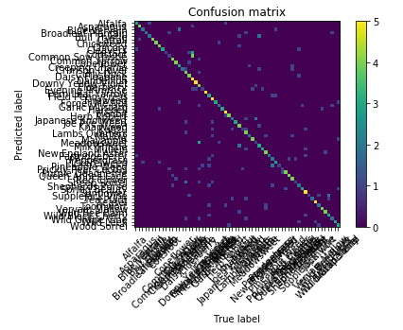
As due to the large number of classes it is not very readable, I am also showing the number of correct predictions, per class, out of the 5 maximmum correct predictions. I am using these to target the classes where the algorithm performs the worst, and invest time to find and provide more training images.

Check how many right predictins we have, out of 5 examples per each class:
Correct predictions for class Alfalfa : 3
Correct predictions for class Asparagus : 4
Correct predictions for class Blue Vervain : 2
Correct predictions for class Broadleaf Plantain : 2
Correct predictions for class Bull Thistle : 2
Correct predictions for class Cattail : 4
Correct predictions for class Chickweed : 4
Correct predictions for class Chicory : 4
Correct predictions for class Cleavers : 3
Correct predictions for class Coltsfoot : 1
Correct predictions for class Common Sow Thistle : 1
Correct predictions for class Common Yarrow : 4
Correct predictions for class Coneflower : 4
Correct predictions for class Creeping Charlie : 3
Correct predictions for class Crimson Clover : 2
Correct predictions for class Curly Dock : 4
Correct predictions for class Daisy Fleabane : 4
Correct predictions for class Dandellion : 5
Correct predictions for class Downy Yellow Violet : 5
Correct predictions for class Elderberry : 4
Correct predictions for class Evening Primrose : 1
Correct predictions for class Fern Leaf Yarrow : 5
Correct predictions for class Field Pennycress : 3
Correct predictions for class Fireweed : 5
Correct predictions for class Forget Me Not : 3
Correct predictions for class Garlic Mustard : 2
Correct predictions for class Harebell : 3
Correct predictions for class Henbit : 5
Correct predictions for class Herb Robert : 4
Correct predictions for class Japanese Knotweed : 2
Correct predictions for class Joe Pye Weed : 3
Correct predictions for class Knapweed : 4
Correct predictions for class Kudzu : 1
Correct predictions for class Lambs Quarters : 4
Correct predictions for class Mallow : 2
Correct predictions for class Mayapple : 4
Correct predictions for class Meadowsweet : 1
Correct predictions for class Milk Thistle : 3
Correct predictions for class Mullein : 3
Correct predictions for class New England Aster : 4
Correct predictions for class Partridgeberry : 2
Correct predictions for class Peppergrass : 2
Correct predictions for class Pickerelweed : 3
Correct predictions for class Pineapple Weed : 1
Correct predictions for class Prickly Pear Cactus : 1
Correct predictions for class Purple Deadnettle : 4
Correct predictions for class Queen Annes Lace : 4
Correct predictions for class Red Clover : 4
Correct predictions for class Sheep Sorrel : 1
Correct predictions for class Shepherds Purse : 2
Correct predictions for class Spring Beauty : 3
Correct predictions for class Sunflower : 5
Correct predictions for class Supplejack Vine : 1
Correct predictions for class Tea Plant : 2
Correct predictions for class Teasel : 5
Correct predictions for class Toothwort : 2
Correct predictions for class Vervain Mallow : 4
Correct predictions for class Wild Bee Balm : 4
Correct predictions for class Wild Black Cherry : 3
Correct predictions for class Wild Grape Vine : 2
Correct predictions for class Wild Leek : 3
Correct predictions for class Wood Sorrel : 3
Reflection

I guess the biggest challenge was to try to solve a deep learning problem with very limited computational resources.

While the accuracy on the test set is already not too bad, this is still a prototype. Prediction accuracy of user images is not yet too accurate. Also, the model seems sometimes to be 100% sure of the predicted class, also when it is wrong. The model still mistakes a Lamborghini for a Daisy Fleabane. I believe there are 2 main reasons for this:
- The very limited size of the training dataset
- The very small size of the input image to the model (100x100px)

Both shortcomings can be solved if more time and resources were available.

Ideas for further improvement

To take this application into production, the following steps can be taken, to improve test dataset accuracy:
- Increase input image sizes to the CNN model from 100x100px to 224x224px – this would take much more computing power, though
- Try to reduce overfitting by reducing the model’s complexity
- Gather more training images, off the internet and doing photo-shootings in the nature

I am certain that the performance of the actual solution could be improved, by taking the above-mentioned actions.

References

Metrics
https://www.ncbi.nlm.nih.gov/pmc/articles/PMC4614595/

Image color profiles:
https://en.wikipedia.org/wiki/YCbCr
Preprocessing and reading images:
https://machinelearningmastery.com/multi-class-classification-tutorial-keras-deep-learning-library/

OpenCV:
https://opencv-python-tutroals.readthedocs.io/en/latest/py_tutorials/py_gui/py_image_display/py_image_display.html

StratifiedKFold:
http://scikit-learn.org/stable/modules/generated/sklearn.model_selection.StratifiedKFold.html

Plant Species Identification Using Computer Vision Techniques:
https://link.springer.com/article/10.1007/s11831-016-9206-z

VGG16 architecture:
https://www.pyimagesearch.com/2017/03/20/imagenet-vggnet-resnet-inception-xception-keras/

Vanilla CNN model:
http://adventuresinmachinelearning.com/keras-tutorial-cnn-11-lines/

Checkpoints:
https://machinelearningmastery.com/check-point-deep-learning-models-keras/

https://medium.com/@14prakash/transfer-learning-using-keras-d804b2e04ef8

Overfitting CNN models:
https://towardsdatascience.com/deep-learning-3-more-on-cnns-handling-overfitting-2bd5d99abe5d

